Add Broadband Service Over Cable

Version Control:

Use Case Name: |  | Add Broadband Service Over Cable
Use Case Owner: |  | Sumit Borade
Current Version |  | 0.4
Use Case Version History
Modified Date | Version |  | Modified By | Change Description
June 24, 2009 | 0.1 |  | Tom Schnarr | Initial Version
July 8, 2009 | 0.2 |  | Tom Schnarr | Changed future date handling within Triple
August 25,2009 | 0.3 |  | Sumit Borade | Removed the steps not relevant to SMP. Added new steps to show the reply path to ASU and Triple.
Oct 31,2009 | 0.4 |  | Sumit Borade | Added the Static IP Provisioning Steps

Brief Description:
This use case describes the process by which a YouSee subscriber orders broadband services and that service is activated. The use case is written from the perspective of the SMP provisioning solution.

Related Documents
- YouSee SMP SOW2Architecture Requirements Document
- YouSee SMP SOW2 Business Requirements Document
- Voice over Cable Use Case Activation
- Cisco BACC TC Specification
- CISCO Subscriber Manager TC Specifications
- IP History TC Specifications
- Static IP Notifications TC Specs

Related Use Cases

Pre-Conditions
- Subscriber resides in a residence served by YouSee cable footprint
- Subscriber is an acceptable credit risk.

Post-Conditions
- Subscriber is free to use Broadband over Cable service.

Use Case

Primary Flow Diagram
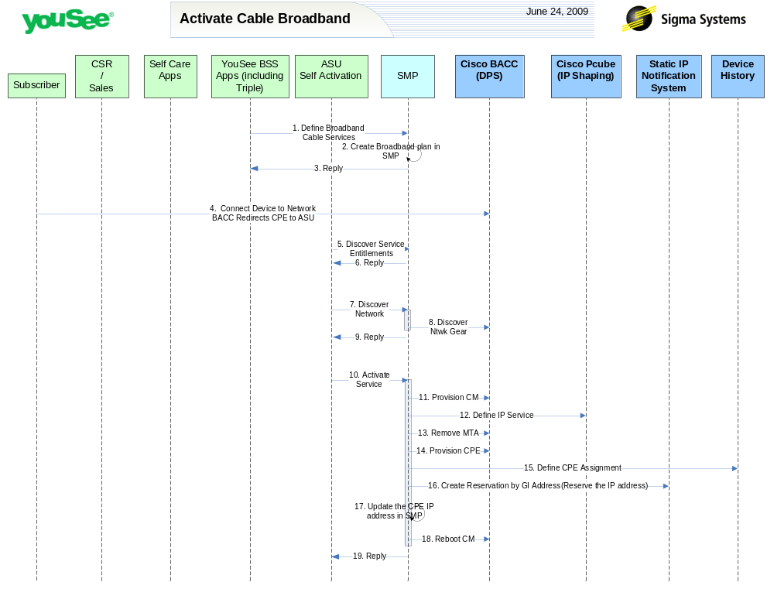

Primary Flow Detail
# | Actor: Key Action | Description | Alternate Flows/Details
 | YouSee BSS: Order is communicated to SMP. Subscriber contacts YouSee and orders Broadband over Cable service. | YouSee BSS (Triple) will communicate the order to SMP through SMP’s Order Management API. Triple will provide logical services and service attributes. SMP will be required to translate these service/service attributes to engineering level resources and resource attributes. | If the subscriber ordered a ‘leased’ CM, YouSee arranged to ship the device to the customer.  If the subscriber ordered a ‘professional installation’ YouSee schedules a technician for the installation.
 | SMP: Broadband Cable Service Plan is created in SMP | Broadband Cable Service plan is created in SMP. SMP will not provision on Network elements since equipment information is not available.
 | SMP: SMP will reply back the status of Order to Triple | SMP will reply back the status of the Order to Triple.
 | Subscriber: Installs CM and PC and launches a browser. Network (BACC) redirects browser to ASU | The Subscriber installs the CM, connects to coax cable and connects a PC to the Ethernet or USB port of the CM.  The CM will range with the CMTS and perform initial DHCP requests initiating network access. BACC will assign the CM, (optional MTA) and CPE a default configuration assigning the CPE an IP that has all HTTP traffic redirected to the ASU portal.  The subscriber will launch a browser from their PC which will be redirected to the ASU self activation welcome page. | Alternatively the installation could be preformed by a technician in which case all ‘subscriber’ steps are replaced by ‘technician’
 | ASU: request service entitlements from SMP | ASU will query SMP to discover the services that the subscriber has ordered. Of relevance to ASU will be  - Broadband cable  - WiFi service  - Voice services  - Additional CPEs
 | SMP: SMP sends reply to ASU for Service Entitlement Information | SMP will reply to ASU the Services present in SMP for that particular Subscriber account.
 | ASU: requests SMP to discover network gear | ASU requests SMP to discover the network gear serving this subscriber. ASU provides SMP the IP address of the CPE (generally the PC), SMP Returns:  - CPE MAC  - CM MAC  - MTA MAC (if appropriate)  - CMTS GI address  - WiFi capabilities  - DOCSIS 3.0 capable  ASU maintains the session with this subscriber so this information needs to be saved along with the session. If the information cannot be found an error message will be displayed to the user at this time.
 | SMP: queries BACC and internal inventory to find network gear serving subscriber | Based on the CPE IP address provided by ASU, SMP will query BACC and discover :  - CM MAC  - CPE MAC  - MTA MAC (if appropriate)  - WiFi capabilities – based on the ‘vendor encapsulation options’ retrieved from BACC  - GIAddress of CMTS  - DOCSIS 3.0 Capable
 | SMP: Replies back to ASU the information received from CISCO BACC | SMP will reply back to ASU information retrieved from CISCO BACC for CPE IP address.
 | ASU: requests SMP to activate service | ASU will request SMP to activate service by generating an order in SMP assigning the equipment (returned earlier) to the subscriber profile. This will include:  - CM MAC  - CPE MAC  - MTA MAC (if appropriate)  - WiFi capabilities – based on the ‘vendor encapsulation options’ retrieved from BACC  - GIAddress of CMTS  - DOCSIS 3.0 Capable
 | SMP: defines CM in BACC | SMP will provision the CM in BACC with the correct class of service, dhcp criteria and other properties for the internet speed tier, wifi service and email service.  SMP will first attempt to modify the device configuration in BACC. The device is expected to be recognized in BACC since it was auto discovered when first connected to network. If the device is not known by BACC, SMP will define the device.
 | SMP: defines internet service to CISCO Subscriber Manager | SMP will define the Internet service to CISCO Subscriber Manager application including the service attributes for which this subscriber is entitled
 | SMP: removes MTA from BACC | The MTA is likely to be recognized in BACC as an unprovisioned device. If the subscriber has not ordered voice services but has an eMTA device to provide broadband services, the MTA portion of the device must be removed from BACC. | AF: if the subscriber has ordered Voice service over this device, the MTA entited is updated in BACC defining that voice service.
 | SMP: defines CPE in BACC | For the CPE MAC address supplied from ASU, SMP will define that MAC address as a ‘Computer’ object in BACC.
 | SMP: defines device history | SMP will define the CPE MAC and Subscriber Address related information to YouSee’s device history System.
 | SMP: Provision Optional static IP Service | This step is optional and will only be performed if the IP address requested on the Standard CPE is Static.  SMP will provision the optional static IP Service on YouSee Internal Static IP Notification System. Internal youSee static IP notification system will provision the CISCO DHCP Server by selecting the IP address looking at the IP Scopes for the CMTS and will return SMP the reserved static IP address
 | SMP: Update Static IP Address in SMP System | This step is optional and will only be performed if the IP address requested on the Standard CPE is Static.The static IP Notification system will return the IP address to SMP and will SMP will update the IP address in its data base.
 | SMP: requests BACC to reboot the CM Device | SMP will then request BACC to reboot the CM device resulting in the CM getting the new configuration, MTA to go offline and CPE to be assigned a new public IP Address.
 | SMP: Replies back to ASU the status of Activation | SMP will reply to ASU the status of Provisioning Order to ASU. | If Provisioning fails then SMP will put the Failed task in Manual Queue.

